标题：

Perceptual Requirements for World-Locked Rendering in AR and VR

AR和VR中世界锁定渲染的感知需求

关键词：

ocular parallax, world-locked rendering

眼视差，世界锁定渲染

摘要：

Stereoscopic, head-tracked display systems can show users realistic, world-locked virtual objects and environments. However, discrepancies between the rendering pipeline and physical viewing conditions can lead to perceived instability in the rendered content resulting in reduced immersion and, potentially, visually-induced motion sickness. Precise requirements to achieve perceptually stable world-locked rendering (WLR) are unknown due to the challenge of constructing a wide field of view, distortion-free display with highly accurate head and eye tracking. We present a system capable of rendering virtual objects over real-world references without perceivable drift under such constraints. This platform is used to study acceptable errors in render camera position for WLR in augmented and virtual reality scenarios, where we find an order of magnitude difference in perceptual sensitivity. We conclude with an analytic model which examines changes to apparent depth and visual direction in response to camera displacement errors.

立体头部跟踪显示系统可以向用户展示真实的、世界锁定的虚拟对象和环境。 然而，渲染管道和物理观看条件之间的差异可能会导致渲染内容的不稳定性，从而导致沉浸感降低，并可能导致视觉诱发的晕动病。 由于构建具有高精度头部和眼睛跟踪的宽视场、无失真显示器的挑战，实现感知稳定的世界锁定渲染 (WLR) 的精确要求尚不清楚。 我们提出了一个系统，能够在现实世界的参考上渲染虚拟对象，而在这种限制下不会出现可感知的漂移。 该平台用于研究增强现实和虚拟现实场景中 WLR 渲染相机位置的可接受误差，我们发现感知灵敏度存在数量级差异。 我们得出一个分析模型，该模型检查视深度和视觉方向随相机位移误差的变化。

思考：

什么是世界锁定渲染 (WLR) world-locked rendering

？（比较新的概念）

什么是相机位移误差camera displacement errors

相机位移误差（Camera Displacement Errors）通常指在计算机视觉和摄影测量中，相机位置或姿态估计过程中的误差。这类误差可以涉及到相机在三维空间中的位置（位移）或朝向（姿态）的不准确性。

相机位移误差可能来源于多个方面，包括硬件和算法方面的因素。例如：

硬件误差： 由于相机本身内部参数的不准确性、传感器误差、镜头畸变等硬件问题可能导致相机位移的估计存在误差。

标定误差： 相机标定是确定相机内部参数的过程，标定误差指的是在标定过程中产生的误差，这可能会影响位移的准确性。

特征匹配误差： 在计算相机位移时，通常需要在图像中匹配对应的特征点。特征匹配的不准确性可能导致位移误差。

运动模糊： 在拍摄过程中，如果物体或相机发生快速运动，可能导致图像中的物体模糊，从而影响位移的准确计算。

减小相机位移误差对于许多应用非常重要，特别是在需要高精度的计算机视觉任务中，如三维重建、SLAM（Simultaneous Localization and Mapping）等。研究和采用精确的相机标定方法、使用高质量的传感器以及优化相机位移估计算法等都是降低这类误差的策略。标题：

Post0-VR: Enabling Universal Realistic Rendering for Modern VR via Exploiting Architectural Similarity and Data Sharing

Post0-VR：通过利用架构相似性和数据共享为现代 VR 实现通用逼真渲染

摘要：

To provide users with a fully immersive environment, VR post-processing, which adds numerous realistic effects on the frame after rendering, plays a key role in modern VR systems. Current post-processing is processed separately from normal rendering by the graphics processing unit (GPU). As a result, the GPU needs to first render a high-resolution frame and then add the post-processing effects within a very short time frame. Our in-depth experimental results on commercial VR products demonstrate that the post-processing in VR applications extends the VR frame time by approximately 2X on average. Furthermore, the ever-increasing resolution requirements of modern VR significantly increase the workloads for post-processing in the execution pipeline. This long delay causes VR real-time execution to frequently miss the critical frame-time deadline, thus hurting users’ quality of experience.Based on the analysis of VR post-processing workflow and its common realistic effects, we observe that post-processing shares the same hardware pipeline with normal rendering, and even reuses the intermediate data produced by normal rendering. To fully utilize this hardware-level similarity and capture the data locality, we propose a novel universal realistic rendering architecture for VR, named Post0-VR, which eliminates post-processing by directly merging the common realistic effects into the normal rendering process. Based on our newly proposed VR architecture design, we further propose a dynamic accuracy adjustment method to simplify the normal rendering without hurting users’ perception. The evaluation results on real-world applications demonstrate that Post0-VR can support different types of realistic effects while significantly improving the overall VR rendering performance.

为了给用户提供完全沉浸式的环境，VR 后处理在渲染后的帧上添加大量逼真的效果，在现代 VR 系统中发挥着关键作用。 当前的后处理是由图形处理单元（GPU）与正常渲染分开处理的。 因此，GPU需要首先渲染高分辨率的帧，然后在很短的时间内添加后处理效果。 我们对商业 VR 产品的深入实验结果表明，VR 应用中的后处理将 VR 帧时间平均延长了约 2 倍。 此外，现代 VR 不断提高的分辨率要求显着增加了执行管道中后处理的工作负载。 这种长时间的延迟导致 VR 实时执行经常错过关键帧时间期限，从而损害用户的体验质量。通过对 VR 后处理工作流程及其常见现实效果的分析，我们观察到后处理共享 与正常渲染相同的硬件管线，甚至复用正常渲染产生的中间数据。 为了充分利用这种硬件级的相似性并捕获数据局部性，我们提出了一种新颖的 VR 通用逼真渲染架构，名为 Post0-VR，它通过直接将常见的逼真效果合并到正常渲染过程中来消除后处理。 基于我们新提出的 VR 架构设计，我们进一步提出了一种动态精度调整方法，以简化正常渲染而不损害用户的感知。 实际应用的评估结果表明，Post0-VR可以支持不同类型的逼真效果，同时显着提高整体VR渲染性能。

思考：

把原来独立的后处理合并到了渲染中，以达到减小开销的目的标题：

VR-NeRF: High-Fidelity Virtualized Walkable Spaces

VR-NeRF：高保真虚拟化步行空间

关键词：

3D imaging; Image-based rendering; Computational photography.

3D 成像； 基于图像的渲染； 计算摄影。

摘要：

We present an end-to-end system for the high-fidelity capture, model reconstruction, and real-time rendering of walkable spaces in virtual reality using neural radiance fields. To this end, we designed and built a custom multi-camera rig to densely capture walkable spaces in high fidelity and with multi-view high dynamic range images in unprecedented quality and density. We extend instant neural graphics primitives with a novel perceptual color space for learning accurate HDR appearance, and an efficient mip-mapping mechanism for level-of-detail rendering with anti-aliasing, while carefully optimizing the trade-off between quality and speed. Our multi-GPU renderer enables high-fidelity volume rendering of our neural radiance field model at the full VR resolution of dual 2K × 2K at 36 Hz on our custom demo machine. We demonstrate the quality of our results on our challenging high-fidelity datasets, and compare our method and datasets to existing baselines. We release our dataset on our project website: <https://vr-nerf.github.io>.

我们提出了一个端到端系统，用于使用神经辐射场对虚拟现实中的步行空间进行高保真捕获、模型重建和实时渲染。 为此，我们设计并建造了一个定制的多摄像头装置，以高保真度密集捕捉可步行空间，并以前所未有的质量和密度提供多视图高动态范围图像。 我们使用新颖的感知色彩空间来扩展即时神经图形基元，以学习准确的 HDR 外观，并使用高效的 mip 映射机制来实现具有抗锯齿的细节级别渲染，同时仔细优化质量和速度之间的权衡。 我们的多 GPU 渲染器能够在我们的定制演示机上以双 2K × 2K、36 Hz 的全 VR 分辨率对神经辐射场模型进行高保真体积渲染。 我们在具有挑战性的高保真数据集上展示了我们结果的质量，并将我们的方法和数据集与现有基线进行了比较。 我们在项目网站上发布了我们的数据集：<https://vr-nerf.github.io>。

思考：

多摄像机（10+）Eyeful Tower的捕捉装置扫描真实场景来建模，通过某些算法来优化渲染效果。该装置由22个相机组成，分布在7个层次上，每个层次有3个相机，顶部还有一个朝上的相机。

提供了展示的github地址，好评。

提出了一个全面的系统，从捕捉到渲染，实现了对可行走的真实世界静态空间的高保真自由视点探索。

本文的动机是为了解决高保真度虚拟可行走空间的捕捉、重建和渲染问题。

IDEA：三维图像分割

标题：

Rendered Tile Reuse Scheme Based on FoV Prediction for MEC-Assisted Wireless VR Service

MEC辅助无线VR服务中基于FoV预测的渲染图块重用方案

关键词：

FoV prediction, mobile edge computing, proximal policy optimization, rendered tile reuse, virtual reality.

FoV 预测、移动边缘计算、近端策略优化、渲染图块重用、虚拟现实。

摘要：

Interactive real-time wireless Virtual Reality (VR) has become increasingly popular because it provides an immersive experience for VR users anytime, anywhere. Introducing multi-access edge computing (MEC) to wireless VR service can solve the problem that VR devices having insufficient rendering power. However, the problem that some tiles in the overlapping field of views (FoVs) may be rendered repeatedly usually be ignored. Repeated rendering would waste the computing resources of edge nodes and damage users' quality of experience (QoE). This paper proposes a rendered tile reuse scheme based on FoV prediction and 3C (caching, computing, and communication) optimization for the MEC-assisted VR service. Firstly, we model the above scheme as an optimization problem that aims to maximize the total users' QoE value under the motion to photons (MTP) delay constraints. Secondly, we use the recurrent neural network model with gated recurrent unit (GRU) architecture to dynamically predict the users' FoV in the next time slot. Thirdly, we use the proximal policy optimization (PPO)to learn the question's solution iteratively based on the results of FoV prediction. The simulation results show that our proposed algorithm is superior to other algorithms in improving the value of total users' QoE and reducing the MTP delay.

交互式实时无线虚拟现实（VR）因其随时随地为VR用户提供身临其境的体验而变得越来越受欢迎。 将多接入边缘计算（MEC）引入无线VR服务可以解决VR设备渲染能力不足的问题。 然而，重叠视场（FoV）中的某些图块可能会被重复渲染的问题通常被忽略。 重复渲染会浪费边缘节点的计算资源，损害用户的体验质量（QoE）。 本文提出了一种基于 FoV 预测和 3C（缓存、计算和通信）优化的渲染图块重用方案，用于 MEC 辅助的 VR 服务。 首先，我们将上述方案建模为一个优化问题，旨在在运动光子 (MTP) 延迟约束下最大化总用户的 QoE 值。 其次，我们使用具有门控循环单元（GRU）架构的循环神经网络模型来动态预测用户在下一个时隙的FoV。 第三，我们使用近端策略优化（PPO）根据 FoV 预测的结果迭代学习问题的解决方案。 仿真结果表明，我们提出的算法在提高总用户QoE值和降低MTP延迟方面优于其他算法。

思考：

渲染跟网络很容易搭边

标题：

Rendering Perceived Terrain Stiffness in VR Via Preload Variation Against Body-Weight  
通过针对体重的预载变化在 VR 中渲染感知的地形刚度

摘要：

PreloadStep is a novel platform that creates the illusion of walking on different types of terrain in Virtual Reality without requiring users to wear any special instrumentation. PreloadStep works by compressing a set of springs between two plates, with the amount of compression determining the perceived stiffness of the virtual terrain. The platform can render perception of stiffness by applying preload forces up to 824 N in different portions of the terrain, capable of changing stiffness illusion even while a user is standing on it. The effectiveness of PreloadStep was tested in two perception studies (perception thresholds and haptic-visual congruence studies) and an example application, with the results indicating that it is a promising method for creating engaging virtual terrain experiences.

PreloadStep 是一个新颖的平台，它可以在虚拟现实中创造出在不同类型的地形上行走的错觉，而无需用户佩戴任何特殊的仪器。 PreloadStep 的工作原理是压缩两块板之间的一组弹簧，压缩量决定虚拟地形的感知刚度。 该平台可以通过在地形的不同部分施加高达 824 N 的预紧力来呈现刚度感知，即使用户站在其上也能够改变刚度错觉。 PreloadStep 的有效性在两项感知研究（感知阈值和触觉视觉一致性研究）和一个示例应用程序中进行了测试，结果表明它是创建引人入胜的虚拟地形体验的一种有前景的方法。

思考：

曹宇可以参考思路，软硬件结合

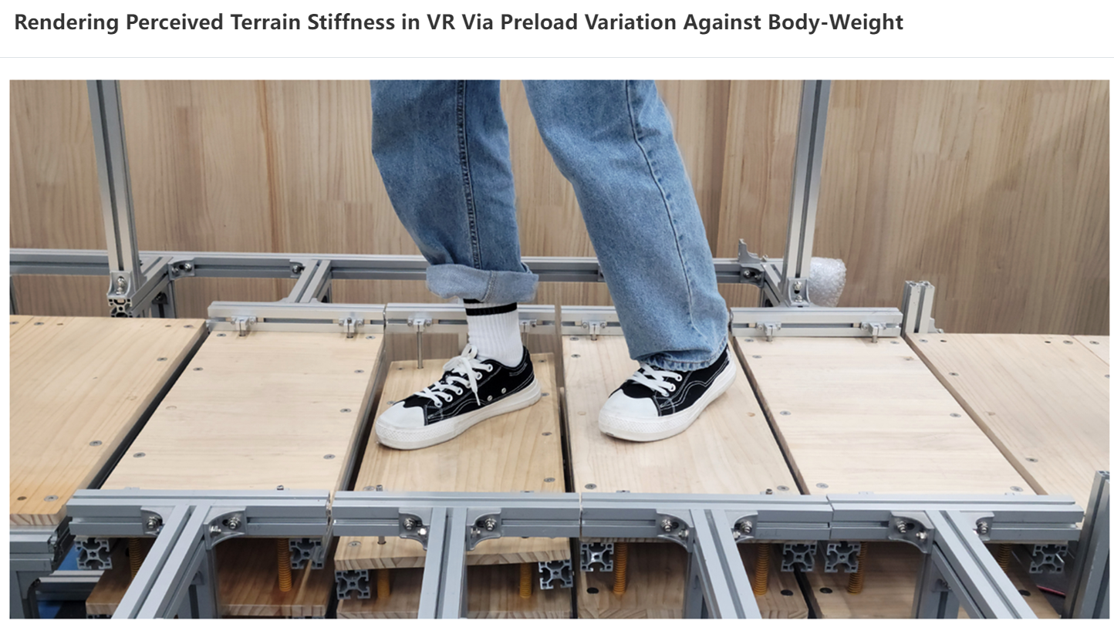

标题：

Foveated rendering: A state-of-the-art survey  
注视点渲染:最先进的调查

关键词：

foveated rendering; virtual reality (VR); real-time rendering

摘要：

Recently, virtual reality (VR) technology has been widely used in medical, military, manufacturing, entertainment, and other fields. These applications must simulate different complex material surfaces, various dynamic objects, and complex physical phenomena, increasing the complexity of VR scenes. Current computing devices cannot efficiently render these complex scenes in real time, and delayed rendering makes the content observed by the user inconsistent with the user’s interaction, causing discomfort. Foveated rendering is a promising technique that can accelerate rendering. It takes advantage of human eyes’ inherent features and renders different regions with different qualities without sacrificing perceived visual quality. Foveated rendering research has a history of 31 years and is mainly focused on solving the following three problems. The first is to apply perceptual models of the human visual system into foveated rendering. The second is to render the image with different qualities according to foveation principles. The third is to integrate foveated rendering into existing rendering paradigms to improve rendering performance. In this survey, we review foveated rendering research from 1990 to 2021. We first revisit the visual perceptual models related to foveated rendering. Subsequently, we propose a new foveated rendering taxonomy and then classify and review the research on this basis. Finally, we discuss potential opportunities and open questions in the foveated rendering field. We anticipate that this survey will provide new researchers with a high-level overview of the state-of-the-art in this field, furnish experts with up-to-date information, and offer ideas alongside a framework to VR display software and hardware designers and engineers.

近年来，虚拟现实（VR）技术已广泛应用于医疗、军事、制造、娱乐等领域。 这些应用程序必须模拟不同的复杂材质表面、各种动态物体和复杂的物理现象，增加了VR场景的复杂性。 当前的计算设备无法实时高效地渲染这些复杂的场景，延迟渲染使得用户观察到的内容与用户的交互不一致，造成不适。 注视点渲染是一种很有前途的技术，可以加速渲染。 它利用人眼的固有特征，在不牺牲感知视觉质量的情况下，以不同的质量渲染不同的区域。 注视点渲染研究已有31年的历史，主要致力于解决以下三个问题。 第一个是将人类视觉系统的感知模型应用到注视点渲染中。 二是根据注视点原理渲染不同品质的图像。 第三是将注视点渲染集成到现有的渲染范例中，以提高渲染性能。 在本次调查中，我们回顾了 1990 年至 2021 年的注视点渲染研究。我们首先重新审视与注视点渲染相关的视觉感知模型。 随后，我们提出了一种新的注视点渲染分类法，然后在此基础上对研究进行分类和回顾。 最后，我们讨论了注视点渲染领域的潜在机会和悬而未决的问题。 我们预计这项调查将为新研究人员提供该领域最新技术的高水平概述，为专家提供最新信息，并提供 VR 显示软件和硬件框架的想法 设计师和工程师。

标题：

关键词：

摘要：

思考：

标题：

关键词：

摘要：

思考：

标题：

关键词：

摘要：

思考：

标题：

关键词：

摘要：

思考：